Vodič Destinacije „Slavonski Brod-Posavina“/ Info Guide of the Destination „Slavonski Brod-Posavina“

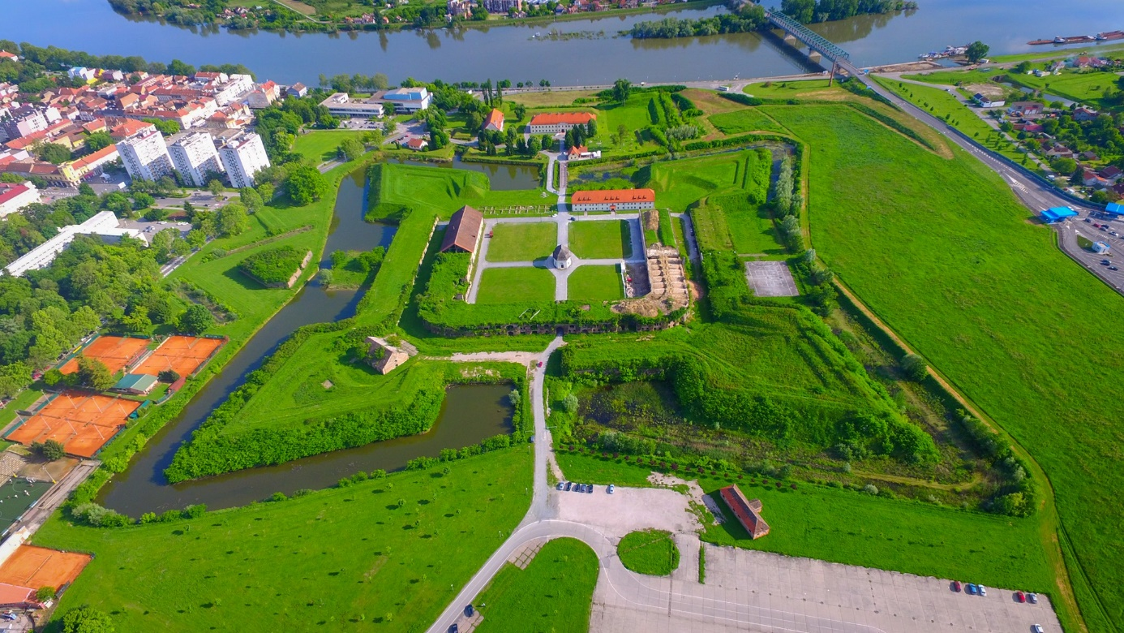
Turistička zajednica područja „Slavonski Brod-Posavina“
/Tourist Board „Slavonski Brod-Posavina“
Trg pobjede 28/1 HR-35000 Slavonski Brod
tel./fax: 00385 35 447 721
e-mail: info@tzgsb.hr

Radno vrijeme/Working hours
Turističko-informativni centar/Tourist Information Center
Trg Ivane Brlić Mažuranić 7a
svaki dan, uključujući nedjelje i praznike/ every day, including Saturdays and holidays
10,00 – 17,00/from 10:00 a.m till 5,00 p.m.
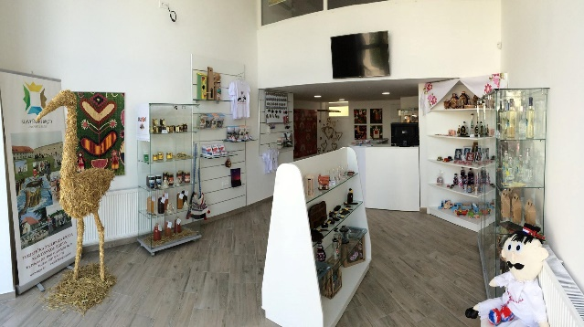
Galerije i muzeji/ Galleries and museums
Galerija Ružić/Gallery Ružić
Tvrđava Brod, Vukovarska 1
od utorka do petka/from Tuesday till Friday
10,00 – 17,00/from 10:00 a.m till 5,00 p.m.
subotom/on Saturdays
10,00 – 14,00/from 10:00 a.m. till 2,00 p.m.
Organizirani posjeti mogući su i
neradnim danima te izvan radnog
vremena, uz prethodnu najavu na
telefone 00385 35 447 680, 448 749, 411 510, odnosno na e-mail: galerija-umjetnina@sb.t-com.hr.

Organized visits are possible on non-working days and outside working hours, with prior notice by phone 00385 35/ 447 680, 448 749, 411 510, or by e-mail: galerija-umjetnina@sb.t-com.hr.
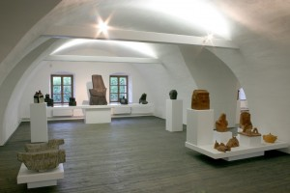
Spomen dom Dragutina Tadijanovića/Memorial Home of Dragutin Tadijanović
Ante Starčevića 8
od ponedjeljka do petka/ from Monday till Friday
8,00 – 16,00/ from 8:00 a.m till 4,00 p.m.
Organizirani posjeti mogući su i
neradnim danima te izvan radnog
vremena, uz prethodnu najavu na
telefone 00385 35 447 680, 448 749, 411 510, odnosno na e-mail: galerija-umjetnina@sb.t-com.hr.

Organized visits are possible on non-working days and outside working hours, with prior notice by phone 00385 35 447 680, 448 749, 411 510, or by e-mail: galerija-umjetnina@sb.t-com.hr.
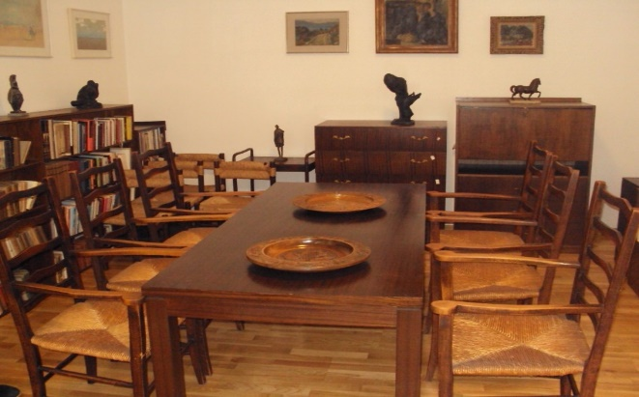

Muzej tambure/Tambura Museum
Tvrđava Brod, Vukovarska 1
http://www.but.hr/muzej_tambure.php
Posjeti su mogući uz prethodnu najavu na
telefon 00385 98 226 707, odnosno na e-mail: but@but.hr
Visits are possible with prior notice by phone 00385 98 226 707, or by e-mail: but@but.hr
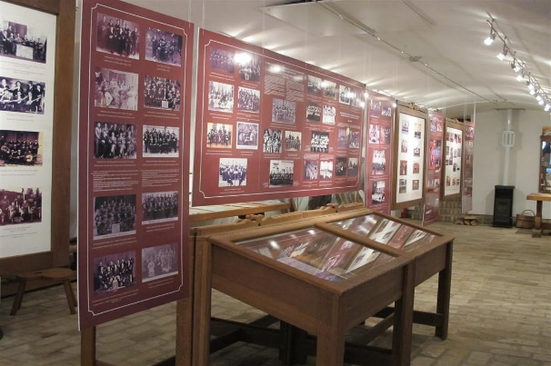

Kuća Brlić/ House of Ivana Brlić Mažuranić
ponedjeljakom/ on Mondays
9,00- 14,00/ from 9,00 a.m. till 2,00 p.m.
od utoraka do petka/ from Tuesday till Friday,
9,00- 14,00/ from 9,00 a.m. till 2,00 p.m.
17,00-19,00/from 5,00 p.m. till 7,00 p.m.
subotom/ on Saturdays
10,00 -14,00/ from 10,00 a.m. till 2,00 p.m.
18,00-20,00/from 6,00 p.m. till 8,00 p.m.
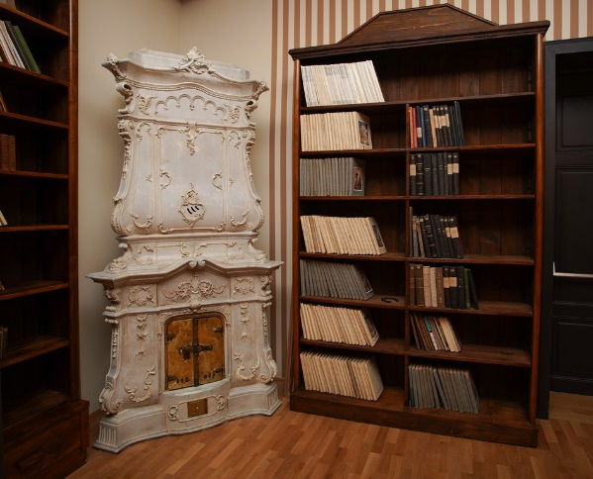
Mjenjačnice/Exhange offices
od utorka do petka/ from Tuesday till Friday
8,00 – 19,00/ from 8:00 a.m till 7,00 p.m.
Subotom/on Saturdays
8,00 – 13,00/from 8:00 a.m. till 1,00 p.m.

Trgovački centri/Shopping centers
Kaufland
Naselje Slavonija II 5
od ponedjeljka do subote/from Monday till Saturday
7,00 – 22,00/from 7,00 a.m. till 10,00 p.m.
Eurospin
Ul. Petra Svačića 2B, 35000
od ponedjeljka do subote/from Monday till Saturday
7,00 – 22,00/from 7,00 a.m. till 10,00 p.m.
Lidl
Trg hrvatskog proljeća 9
od ponedjeljka do subote/from Monday till Saturday
7,00 – 21,00/from 7,00 a.m. till 9,00 p.m.
Lidl
Osječka ulica 280c
od ponedjeljka do subote/from Monday till Saturday
8,00 – 21,00/from 8,00 a.m. till 9,00 p.m.
Plodine
Sjeverna vezna cesta 31
od ponedjeljka do subote /from Monday till Saturday
7,00 – 22,00/from 7,00 a.m. till 10,00 p.m.
Interspar SUPERNOVA
Osječka ulica 284
od ponedjeljka do subote/from Monday to Saturday
7,00 – 21,00/from 7,00 a.m. till 9,00 p.m.
Spar
Petra Svačića 2
od ponedjeljka do subote/from Monday till Saturday
7,00 – 21,00/from 7,00 a.m. till 9,00 p.m.
Pevex
Naselje Slavonija II 4
od ponedjeljka do subote/from Monday till Saturday
7,30 – 20,30/from 7,30 a.m. till 8,30 p.m.
Konzum
Ul. Josipa Jurja Strossmayera 30
od ponedjeljka do subote/from Monday till Saturday
7,00 – 21,00/from 7,00 a.m. till 9,00 p.m.
Emmezeta
Ulica hrvatskih branitelja bb, Gornja Vrba
od ponedjeljka do subote/from Monday till Saturday
7,00 – 21,00/from 7,00 a.m. till 9,00 p.m.
Fis d.o.o.
Osječka bb
od ponedjeljka do subote/from Monday till Saturday
8,30 – 19,00/from 8,30 a.m. till 7,00 p.m.
Informacije o radnim nedjeljama trgovačkih centara dostupne su na web stranicama istih./Information about working Sundays in shopping centers is available on their websites.

Dežurstva/Duties
Dom zdravlja/Health center
Borovska 5
tel. 00385 35 210 600
Centralna ljekarna/Central pharmacy
Vukovarska 10
tel. 00385 35 447 838
Javni prijevoz/Public transport
Autobusne linije/Bus lines
Informacije/Information:
Autobusni kolodvor/Central bus station
Trg hrvatskog proljeća bb
tel. 00385 60 810 810
Željeznički promet/Railway lines
Informacije/Information:
Željeznički kolodvor/Central railway station
Trg hrvatskog proljeća bb
tel. 00385 35 444 787
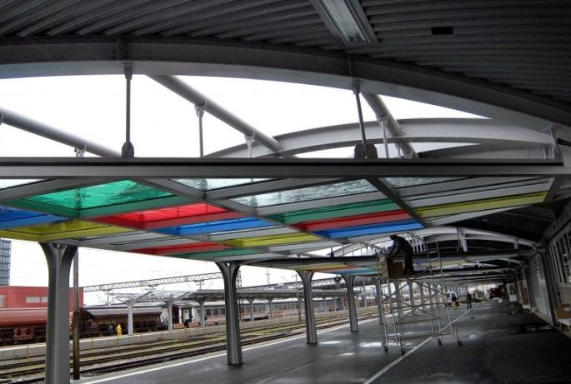
Taxi
Informacije/Information:
tel.00385 98 263 639; 91 430 00 01; 99/333 32 22; 91/450 35 00; 98 303 693; 99 518 65 94; 91/166 86 68; 91/338 38 39
Stajališta/Stands: Autobusni kolodvor/Central bus station; Trg Ivane Brlić Mažuranić; Opća bolnica/General hospital, Andrije Štampara 42
Lokalni prijevoz/Local public bus lines
- prema voznom redu objavljenom na Autobusnom kolodovoru/ according to the timetable published at the Central bus station
- od ponedjeljka do petka, u intervalu od 5,00 do 23.00 sata, prosječno svaki sat/from Monday till Friday, in the interval from 5.00 a.m.till 11.00 p.m., on average every hour
- subotom, u intervalu od 5,00 do 2,00 sata idućeg dana, prosječno svakih sat i po/on Saturdays, in the interval from 5.00 a.m. to 2.00 a.m. the next day, on average every hour and a half
- nedjeljom, u intervalu od 6,00 do 21,00 sat, prosječno svaka dva sata/ on Sundays, in the interval from 6.00 a.m. till 9,00 p.m., on average every hour and a half
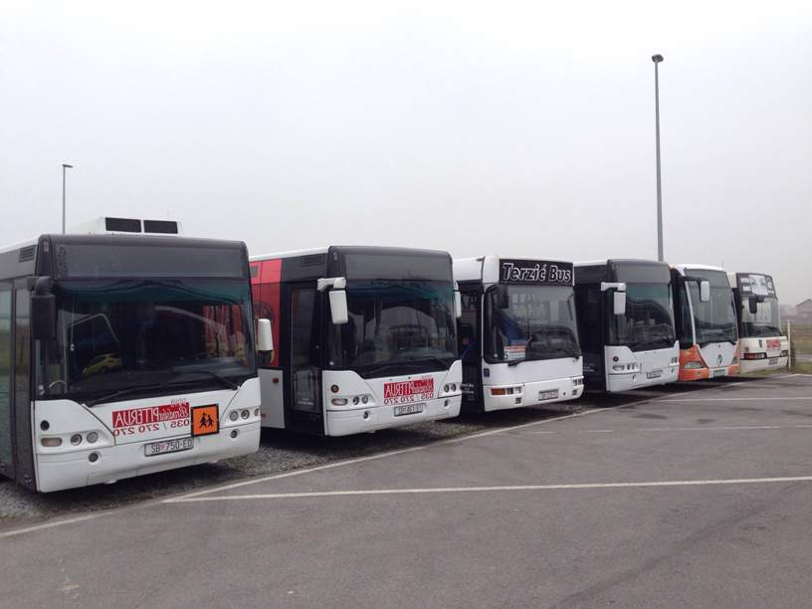

Parkiranje/Parking
uz plaćanje putem automata,slanjem sms poruke koja sadržava registracijski broj vozila ili putem mobilnog telefona na broj 708351 za zonu I i na broj 708352 za zonu II/with payment via automat; by sending an SMS message containing the registration number of the vehicle or by mobile phone to the number 708351 for zone I and to the number 708352 for zone II

